Keith Baker
Executive Director
ReConnect Rondo
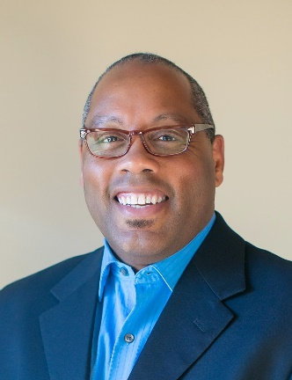
Keith Baker is the executive director for ReConnect Rondo, an umbrella advocacy organization committed to addressing racial disparities in Minnesota. Keith is leading the organization’s mission to revitalize the Rondo community of St. Paul with a 21-acre land bridge that reconnects the historic African American community and creates Minnesota’s first African American cultural enterprise district. Keith has more than 35 years of experience in the public, private and nonprofit sectors. His 18 years with the Minnesota Department of Transportation included oversight of federal and state professional technical contract administration and construction compliance monitoring. Keith served as a member of the Ramsey County Blue Ribbon Commission in 2010, which was in the forefront of elevating Minnesota’s ranking as 50th in the nation for racial disparities. Over the years, he has identified and executed strategies supportive of equitable development, entrepreneurism, ownership, business and workforce development, and opportunity access.
As a strategist, connector and influencer, Keith has a reputation for seeing the big picture, along with the connective links needed for genuine progress. He’s known for skillfully navigating within constrained environments, creating outputs that result in equitable outcomes. These characteristics were instrumental in the successful orchestration of a collective impact approach that ensured equitable inclusion of minority- and women-owned engineering and architect firms on the billion-dollar U.S. Bank Stadium project.

